|  |  |
| --- | --- |
| **Business Process:** | **Business Technology Office - SUNTAX** |
| **Tax Type:** | **All** |
| **Activity:** | **Creating Leads for ECO Team using ZICM_WORKLIST** |
| **Sub-Activity:** | **New Registration** |

**Purpose/Objective**

GTA’s new Education and Compliance Outreach (ECO) program will be managed and reported from Integrated Compliance Management (ICM). ECO leads will be created and managed using ZICM_WORKLIST.

**Steps**

Before creating a lead referral, use transaction ZCIC to verify each business partner number is a new registration. Do not create a lead if the account shows collection or audit activities, has a START letter previously mailed, or has a Voluntary Disclosure case.

**ZICM_WORKLIST**

Enter ZICM_WORKLIST in the Command field.

Click .

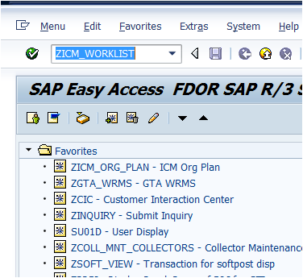

The “ICM Work List – Audit / Campaigns” screen displays.

Click the Create Lead Referral button.

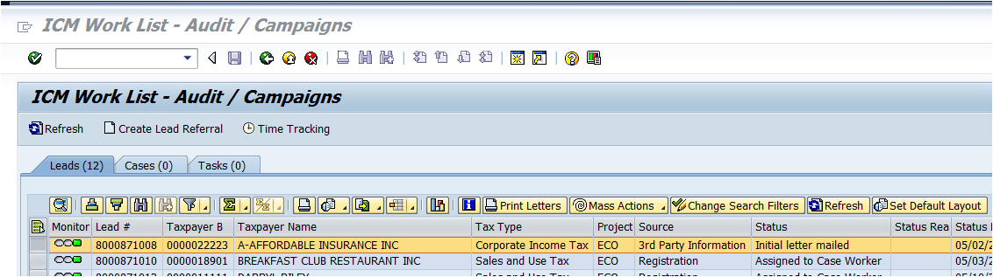

The Create Lead Referral window displays.

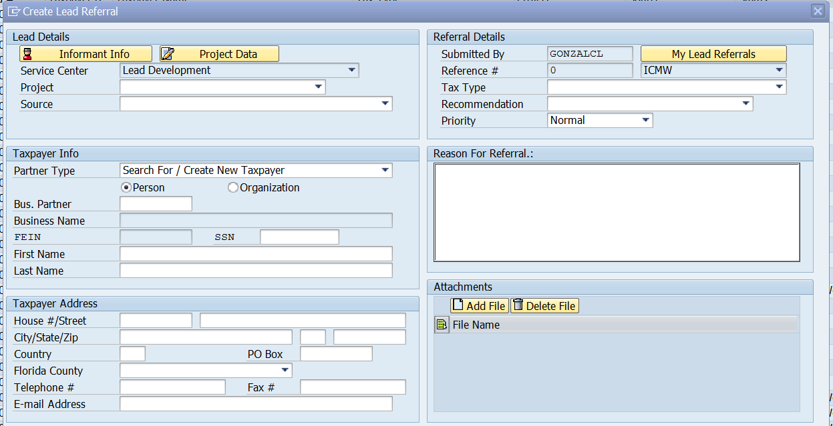

The following screen shots isolate each section of the Create Lead Referral window and provide information the ECO team will use to create the lead.

**Lead Details Section**

Select ECO as the Project.

Select Registration as the Source.

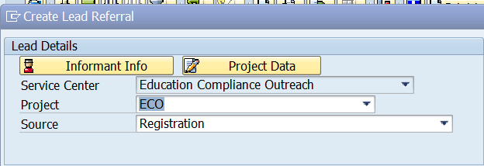

***Note: Service Center defaults to Education Compliance Outreach when the ECO Caseworkers updates the Project drop down to ECO.***

The following Source options are available for ECO leads:

|  |  |
| --- | --- |
| 3rd Party Information | Registration |
| Commercial Rental | Special Events |
| Estimated Tax Filers | Subjectivity |
| Frequency Change | Transient Rental |
| Lexus Nexis | Various |
| Manual Request |  |

**Taxpayer Info Section**

Select Search For / Create New Taxpayer.

Select Person or Organization.

Enter BP # in Bus. Partner field and press the Enter key.

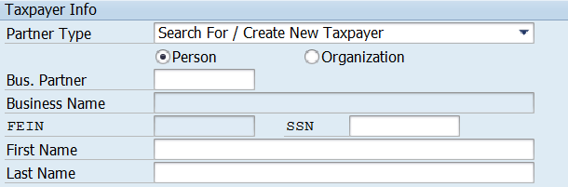

***Note: The taxpayer’s social information will auto-populate after you enter the BP number and press Enter.***

If you select Person, the following information will auto-populate:

**First Name Field** - First Name of Taxpayer

**Last Name Field** - Last Name of Taxpayer

**SSN Field** – Taxpayer’s Social Security Number

If you select Organization, the following information will auto-populate:

**Business Name Field** - Business Name

**FEIN Field** – Business’ Federal Employer Identification Number

**Taxpayer Address Section**

Fields are auto-populated with BP standard address information.

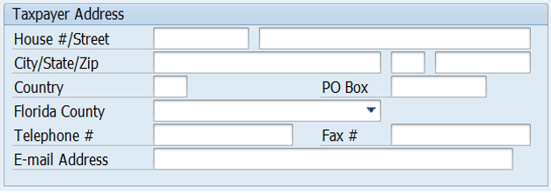

***Note: These fields auto-populate with the taxpayer’s standard address information after you enter the BP number in the Taxpayer Info section and press Enter. You can change this to the mailing address, if necessary.***

**Referral Details Section**

Select the tax type.

Select ECO as the Recommendation.

Select priority (defaults to Normal).

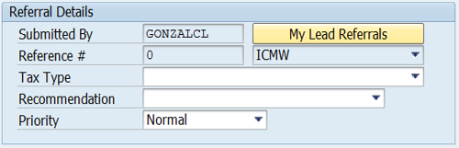

***Note: The Reference # field is not used for ECO leads.***

**Submitted by Field** – defaults with User’s ID

**Reference # Field** - Not in use for ECO

**Tax Type Field** - Tax Type drop down

**Recommendation Field** - For this type of Lead, choose ECO

**Priority Field** - Priority of the Lead (leave as Normal unless otherwise instructed)

**Reason for Referral Section**

Enter New Registration as the reason for referral.

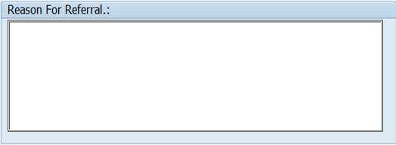

***Note: This is a required field. For this type of lead, enter “New Registration”.***

**Attachments Section**

Use the Add File button to attach a file to the lead, if needed. For example, the Power of Attorney form may be attached.

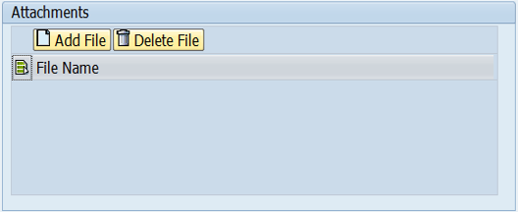

***Note: Users who create an attachment may remove it using the Delete File button.***

**Create and Cancel Buttons**

Click Create Referral.



When you have completed entering all required information for the lead, click the Create Referral button. Use the Cancel button to cancel the action; the lead will not be created.

After you click Create Referral, the Lead Created window displays with the case number and a successful creation message. The lead is now assigned to you and displays in your worklist.

